**CHAPTER FOUR**

**4.0. Implementation and Evaluation**

This will follow the methods set out in the design. After the system has been developed much work is required to test develop system. During this stage, operational document such as scheduling output distribution, source of input balancing instruction and jobs control languages are turned over to the operation.

**4.1. Implementation of the Platform**

Implementation is the acquisition and integration of the physical and conceptual resources that produce a working platform. It can also be defined as the process of carrying out the detailed instructions needed for the platform to work as planned. It is also concerned with the coordination and controlling of the activities necessary to put the platform into operation if possible i.e. continuing to run the old platform for a while when the new platform is introduced so that the new platform is fully the old platform to the new platform.

At this stage, the physical resources acquired and integrated with the conceptual resources in order to achieve the set objectives.

The stages of implementation are:-

1. Announce implementation
2. Obtain hardware and software resources
3. Prepare database
4. Prepare physical facilities
5. Education participants
6. Documentation
7. Change over

**4.1.1. Location and Installation**

This platform should be implemented at the headquarters of the platform developer; the room to house the platform’s server must be kept in a condition that will guarantee efficiency of the platform.

Infrastructural development such as earthling the building where the computer will be installed, removal of the old cabinets, installations of new disk drawers for safekeeping of diskettes and the installations of air conditions for adequate ventilation are all needed.

**4.1.2. Student Development and Needs**

The relevant student to operate the platform is going to be trained. Each student involved in the exercise should have his/her details stored in the platform. The student who are to use the platform should also be properly informed of the impending changes.

**4.2 Hardware and Software Requirements**

**Hardware Requirement**

* Personal computer (Pentium IV)
* Processor (minimum of 1GHZ speed)
* RAM (250MB minimum, 512MB recommended)
* CD rewritable drive
* Flash disk (126mb)
* Memory (2GB free space)
* Enhanced keyboard
* Mouse (optical-recommended)
* SVGA resolution (728 X 1024)
* Stabilizer (1000KIN) UPS 600
* Color printer (all-in-one)

**Software Requirements**

* MySQL server
* JAVA
* Internet browser
* Wampserver
* Text editors
* PHP

**4.3. Performance Criteria**

There are certain criteria that are used in measuring the performance of a system that has just been implemented. These include: -

1. Cost
2. Productivity
3. Time
4. **Cost Element**: - The cost includes all the cost involved in the analysis. These development investigation, design and programming, implementation and evaluation also maintenance of the platform. The cost should be at an affordable rate. Also included in the cost elements are costs of human ware, software and hardware
5. **Productivity**: - This entails a measurement of the relationship between input and output. It assesses the volume of the input fed in to computer for processing.

**4.4. Programming Language Used**

Programming involves the transaction of the systems specification into usable machine instructions that produce desired results. It can equally be looked upon as an act of writing detailed instruction set or code in a specified computer language that directs the computer system to carry out a specific task. Finally it can be defined as the art of communicating with the computer system in a language it can understand, programming involves writing programs that are reliable maintainable, portable and readable, can perform and save storage space. The stages involved in programming are pseudo, code, (program flowchart, program writing, and desk checking etc. this particular research work underwent all these stage before recommended as a better alternative to the manual system. The JAVA, javascript computer language was used in the study.

**4.5. Maintenance**Maintenance can be defined as changes or modifications in hardware, software, documentation or procedures to a production system in order to correct error that might arise, met new requirement or improve processing efficiency. It is quite necessary to continually main modify an existing system. Program maintenance is an important task of the programmer and they involves all steps from problem definition through analysis, design and program preparation, program maintenance takes a lot of programming effort. Maintenance could be preventive, corrective, perfective or adaptive.

1. **Preventive Maintenance**: - The preventive maintenance involves a regular inspection and cleaning of the system to prevent fault (or errors) and to forestall breakdown of the system.
2. **Corrective Maintenance**: - This maintenance uncovers bugs in the program or weakness in the design that were not detected during system testing. These errors are detected and correct during the maintenances period. This type of faults includes changing of worn out of burnt out components like fuse wire, transistors transformers, Etc. and the replacement of worn out plays heads and drive heads in a computer system.
3. **Perfective Maintenance**: - This aspect of maintenance is meeting the set objectives, it also refers to technical improvement on an existing system that does not require any alternative to the basic design of the system.
4. **Adaptive Maintenance**: - This type of maintenance is adapted to any situation or circumstance it adapts a system to meet the changing requirements of the meet the of the users of the system. In relation to the computerization and software development of this case study the program of the new system recommended will be continually monitored and maintained in line with the set objectives through perfective corrective, preventive and adaptive methods of maintenance.
   1. **Program Structure**

This program was structured so that it can accommodate as many students as possible. It is flexible too change and/or add new things to: furthermore, the program was designed to include other information that could be required of an students owing to one thing or the other in the future. These things includes complete personal information of the students, The admin and Teachers etc.



**Figure 1: This is the logo of a high level language called JAVA**

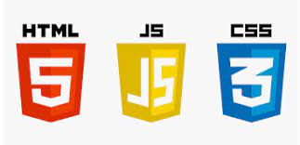

**Figure 2**: **These shows the logos of the main building blocks of a webpage.**



**Figure 3**: **These shows the most popular server-side programming language.**

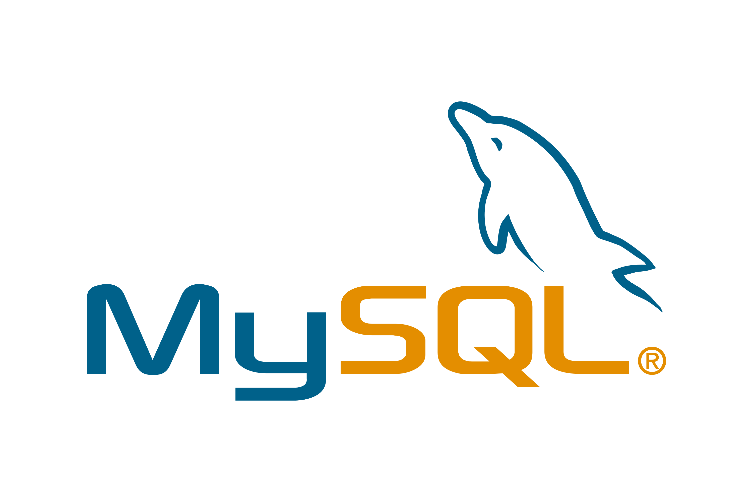

**Figure 4: This is the most popular database management system.**

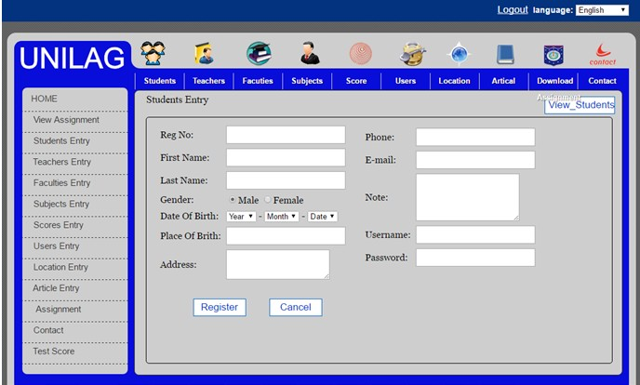

**Figure 5: This is an example of an online assignment submission page.**